MILESTONE ACADEMY
VACATION HOME-WORK
SUBMISSION DATE – 17.06.19 CLASS – VI PC/MS/2019-20/VI/011
-----------------------------------------------------------------------------------------------------------------------------------------------
ENGLISH – 1. Write an account on Radio Jockey. Read the hint questions to help you to write.
Hints :- 1) What is the job of a Radio Jockey? Name a few Radio Jockeys.
2) If you become a Radio Jockey, which topic would you speak on?
Write the script in 50-75 words on how would you present the topic?
2. Select a small story from a magazine. Underline and list the Pronouns,
Adjectives and Prepositions.
3. Write a paragraph and also draw or paste pictures related to the topic ‘A Morning Walk’.
4. Write a letter to God thanking him for giving you a wonderful life with such lovable parents.
5. Collect pictures of cartoon by famous novelist and cartoonist R.K. Laxman and
exhibit through PPT.
6. Write the words denoting the following professions or trades. You can find the words in the
word maze given below:-
- One who keeps accounts for business ________________
- One who write books ________________
- One who draws maps ________________
- One who rides the horses in races ________________
- One who writes for the newspaper & magazines ________________
- A person in charge in museum ________________
- A person who treats diseases by operation ________________
- One who sells small articles ________________
- One who flies an aeroplane ________________
- A person or company offering something for sale ________________

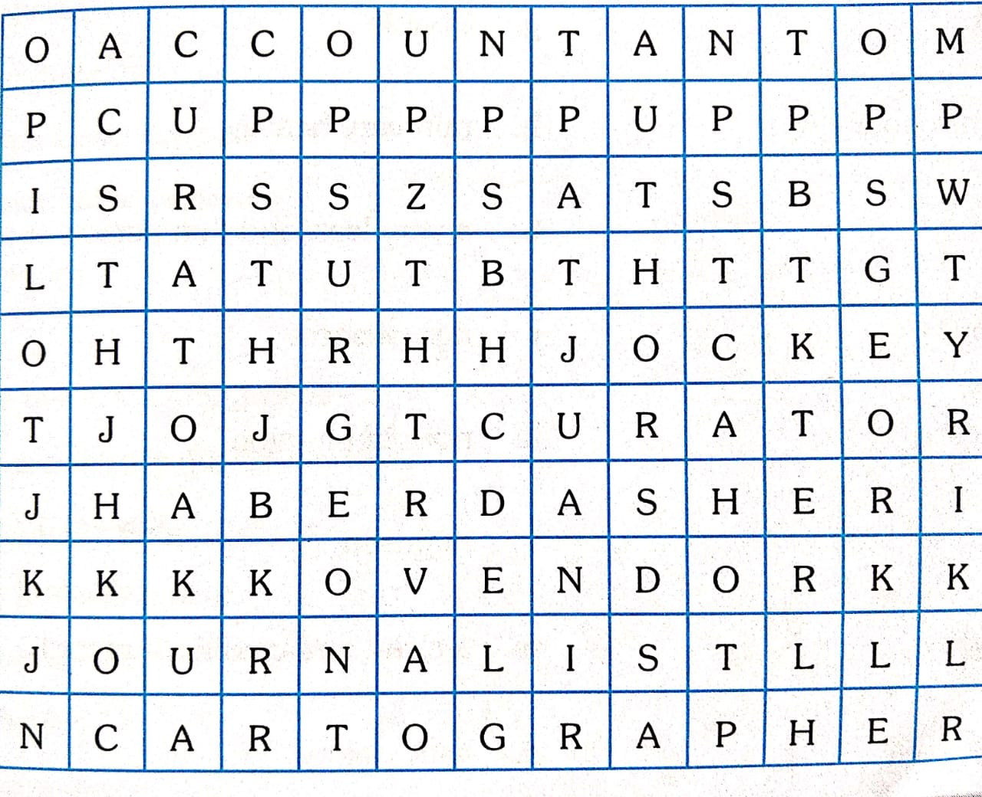

HINDI - 1. vuqukfld o vuqLokj okys 20& 20 'kCn fyf[k, A
2- vius fe= }kjk LoPNrk vfHk;ku esa fd, x, lg;ksx ds fy, c/kkbZ i= fyf[k, A
3- izkpk;kZ dks rhu fnu ds vodk”k ds fy, vkosnu i= fyf[k, A
4- vuqPNsn ys[ku & 1- fctyh dk ln~mi;ksxA
2- ekr`Hkk"kk dk egRoA
3- xfeZ;ksa esa ty&laj{k.k ds fy, eSaus fd, ;s iz;kl ----------------------------
- vius ikB~; iqLrd ds ikBksa ls izR;sd v{kjksa ds dfBu “kCn <wa<dj muds vFkZ fy[kdj
“kCndks”k (Dictionary) cukb,A

6-

SCIENCE – 1. Planning and presentation (on a chart) – Collect various types of fabric from tailor’s shop
2. Collect wrappers of food containing nutrients detail, search and collect information on how
packed foods are harmful? Give a suitable heading.
3. Collect matter on various methods of separation along with diagram & pictures.
4. Prepare a diet chart to provide balance diet to an 11 year old child. The diet chart should
include food items which are not expensive and are commonly available in your area.
5. Draw diagram of certain plants and mention their edible parts.
6. Calculate the BMI (Body Mass Index ) of any five people around you. Find our which
category do they belong. One is done for you.

Categories – Underweight = < 18.5
Normal weight= 18.5 – 24.99
Overweight = 25-29.99
Obese = > 30

S.No | Relation of the person with the student | Weight in kg | Height in metres | BMI = $\frac{Weight in kg}{{\left(Height in metres\right)}^{2}}$ | Category
1 | Mother | 79 kg | 1.65 m | 79 / (1.65)² = 29.01 | Over weight
2
3
4
5
6

7. Study the table and fill in the sources.
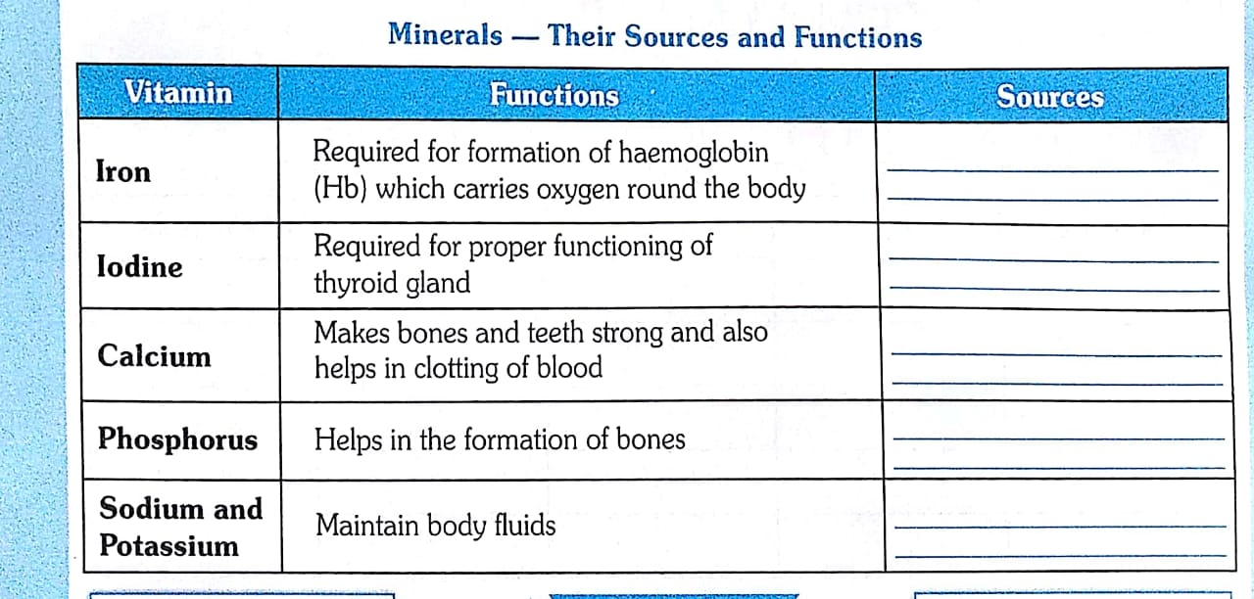

8. Find foods in this word search and write them in the right column:-
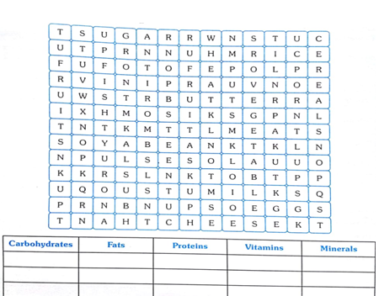

SANSKRIT – 1- ydkj & 1- yV~ ydkj 2- yX ydkj 3- y`Vydkj
2- /kkrq & iB~ ] gl~ ] [ksy ] xe~ ] on~ ]Hkw ¼Hko½
3- dkjd jpuk & 'kCn & ckyd ] ckfydk ] yrk ] ou ]'kkyk ] iq"i ] eqfu
4- vO;; & v= ] r= ] dq= ] vUr% ] cfg% dk vFkZ

SOCIAL SCIENCE – Geography - 1. On ¼ ^{th} chart paper, make a table of eight planets, the time
they take in revolving around the sun , rotation on its axis and
the no. of moons each planet has.
2. Make a list of 29 states with their capitals and locate it on the
political map of India.

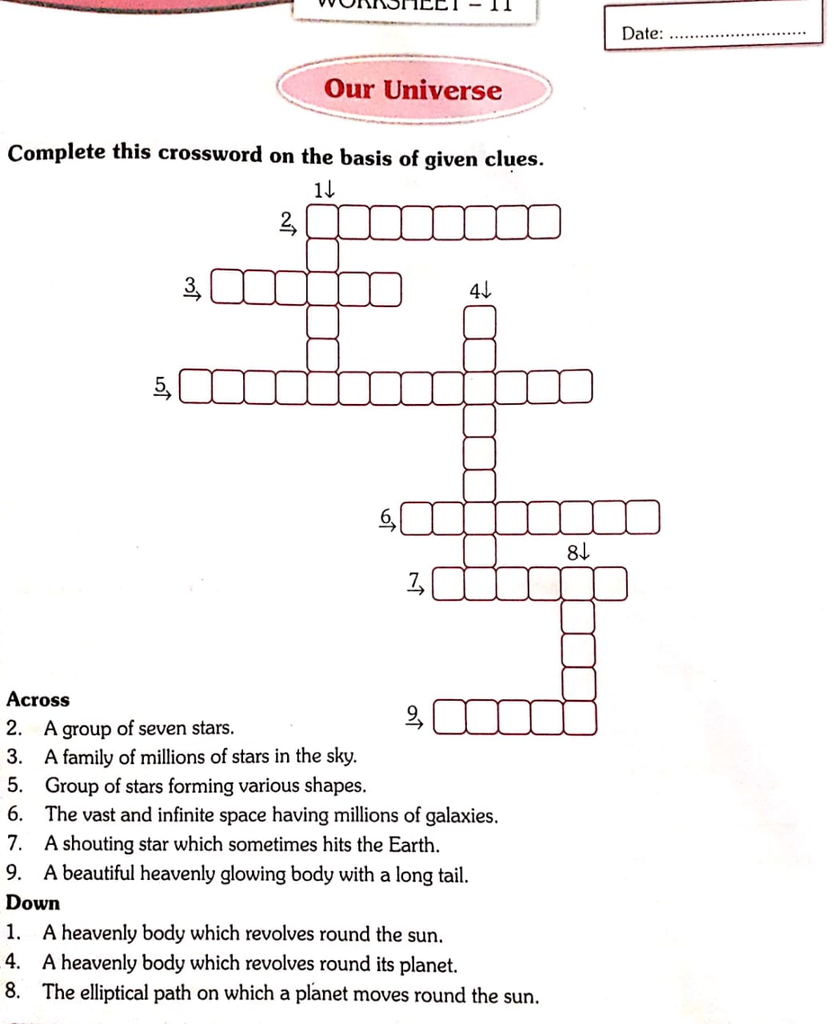

Civics –
Q.1)
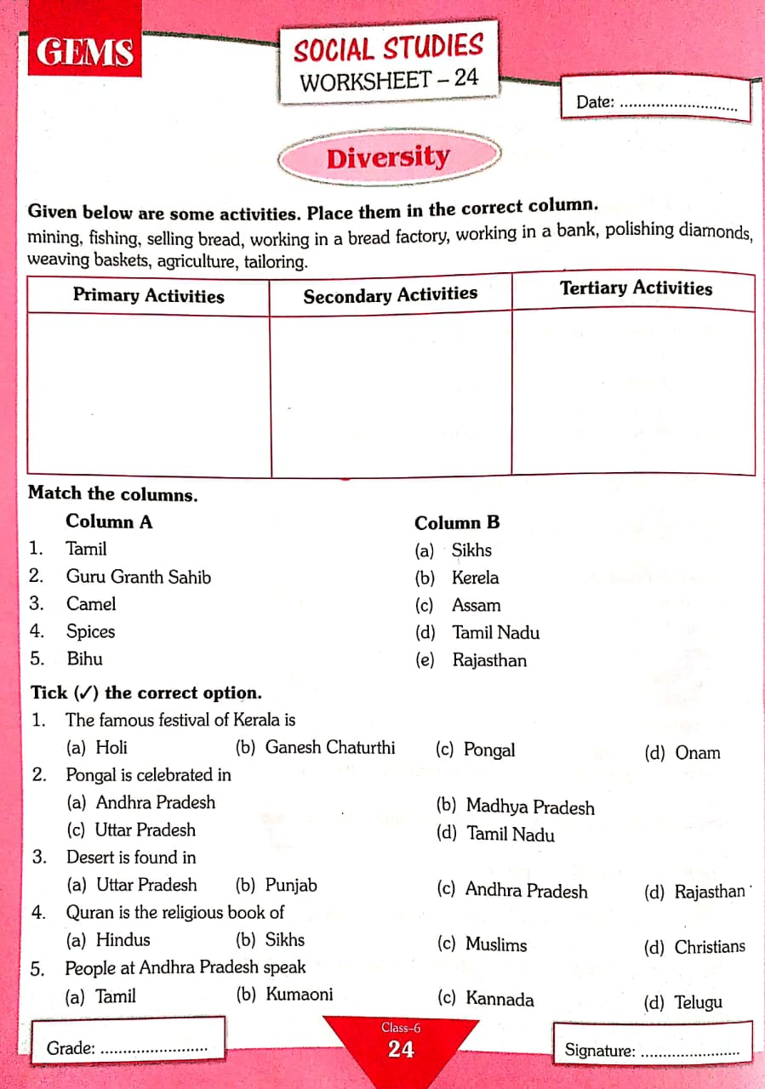
Q.2)
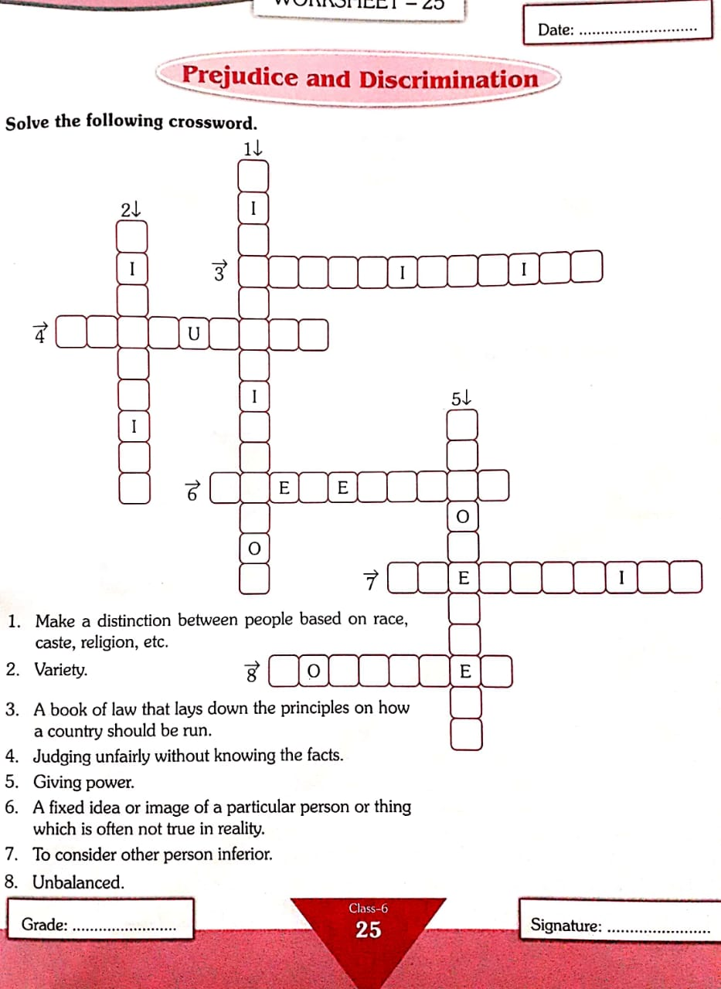

History –
1. Describe the site of Mehrgarh in scrap book.
2. Write 20 objective Question & Answers of Ch-1.
3. Reference Ch-2 : Make a project specifying the different kinds of tools and the dates or when they
were excavated.
MATHS –
1. Prepare an A-Z Maths Dictionary of 50 words in all:-
For example 1) A = Abacus , addition 2) B = BODMAS 3) C = Circle
2. Find the area of Drawing Room / Kitchen / Lawn of your house.
3. Prepare a chart sheet of 2D & 3D shapes with the formulas of their perimeter, areas & volumes.
4. Prepare a chart for mass, capacity, and distance. Write all the units & their relationship like 1m = 100 cm.
5. Given below are the numerals-
1) 3,05,09,012 2) 6, 60, 60, 060
Put them in the place value chart and write in words. Write each one of them in the expanded form
6. Write all the 3-digit numbers using 2, 3, 4 taking each digit only once?
7. What number must be subtracted from 11010101 to get 2635967?
8. The product of two numbers is 13421408. If one of the numbers is 364, find the other
9. Estimate the sum of the nearest thousand:- 32836 + 16466
10. Express each of the following numbers as a Roman number :-
1) 137 2) 174 3) 198 4) 236 5) 341
11. Express each of the following in Hindu – Arabic numerals :-
i) XXIV 2) XLVI 3) LXXXVI 4) XIIX
12. Find the sum by suitable rearrangement :-
1) 15409 + 278 + 691 + 422 2) 1983 + 647 + 217 + 353
13. Using distributive property, determine the following :-
1) 740 x105 2) 947 x 96
3) 996 x 367 4) 968 x 73 + 968 x 27
5) 1063 x 127 – 1063 x 27 6) 8937 x 648 + 8937 x 122 + 893 x 230
14.Write example for each:-
- Two even numbers 3) Two perfect numbers 5) Two twin primes
- Two odd numbers 4) Two prime numbers 6) To co-prime
15. Fill in the blanks:-
- A number is divisible by ________________ if it ends in two zeros, or if the number formed with its last two digits is visible by the same number.
- A number is divisible by ________________ if the sum of its digits is divisible by 3
- A number divisible by place ____________ will have either a 0 or an even number in its ones place
- A number is divisible by ________________ if it has a 0 or 5 in its ones place.
- A number is divisible by ________________ if it has a 0 in its ones place.
- A number is divisible by A number is divisible by ________________ if it ends in three zeros, or if the number formed with its last three digits is divisible by the same number
- A number is divisible by ________________ if it has a 0 or 5 in its ones place.
- A number by ________________ if the sum of its digits is divisible by.
16. Fill in the blanks:-
- 2, 3, 4, 6 and 12 are the ____________ of 2.
- 11, 22, 33 and 44 are ____________ of 11.
- 1, 9, 13, 27 and 39 are examples of ________________ numbers.
- 4, 26, 32 and 50 are examples of ________________ numbers.
- 11, 13, 23 and 37 are examples of ________________ numbers.
- The largest factor of 18 is ______________
- The largest 1-digit prime number is ________________ .
- The ___________ of a number can be greater than or equal to the number.
- ____________ is neither prime nor composite.
- The smallest factor of 15 is ____________.
- The smallest multiple of 12 is ___________.

17. State whether the following are true or false :-
- An even number can never be a prime number.
- There are infinite factors of a number.
- A factor of a natural number is always smaller than or equal to the number itself.
- The numbers 17 and 23 are twin primes.
- A number having only two factors is called a prime number.
- All natural numbers are either prime or composite

18. Write all the integers between the given pairs in ascending and descending order:-

S.NO | Integers | Ascending order | Descending order
1 | 0 and 6
2 | -2 and 2
3 | -8 and -13
4 | -40 and -32

19. Write all the integers between the given pairs in ascending and descending order:

S.NO | Integers | Ascending order | Descending order
1 | -60, 310, 0, -215, 29
2 | -200, 154, -6, 315
3 | -300, 250, -175, 150, -100
4 | -95, -85, 65, 35, -75
5 | 176, -331, 117, -115, 101
6 | 210, -305, -106, 216, -75

20. Choose whether the following statements are true or false. Tick (√) the appropriate box:
- 853 x 1 =8531
- (16 x 100) - (16x1 ) = 16 x 1001
- 96 x 15 = 15 x 96
- 23 x 56 is a whole number
- 4743 x 0 = 4743
- (65x131)-(65x31)=65 x 100
- 79 x 1001 = (79 x 1000) – (79x1)
- 1358 x 1 = 1358
- 38 x (91 x 49) = (38x91)x49
- 88 x 0 = 0

COMPUTER – Write an E-mail to your sister / brother describing about your school annual function,
summer vacation or any event of your school.
CREATIVE EXPRESSION - “My favourite family member.”
Record and write the conversation with your best friend on or during summer vacation :
Eg. - Written conversation
Grandma – Very Good Morning to you .
Granddaughter / son - Good morning Grandma .
What a chirpy morning it is today !
Grandma - So how are you making this morning beautiful?
Granddaughter / son - After breakfast I am visiting my friends place to play.

LIFE SKILLS- Think of situations where you can “give” yourself to others, gifts which money cannot buy – such as kindness, thoughtfulness, courtesy, consideration, good nature, courage, tolerance and appreciation. Do not make up stories. Talk about a genuine act - do not boast. Write the incident and your experience of situations where you had given yourself.
---------------------------------------------------------------------------------------------------------------------------

